Survey configurator

Installation guide

Contents

**No table of contents entries found.**

# 1.Installation

## 1.1 System requirements

-Operating System: Windows 7 or higher

-Hardware:

-RAM: 512 MB (minimum), 1 GB (recommended)

-.NET framework installed

-connectivity to SQL server

-permission to create/edit/delete files

## 1.2 Unpacking files

-Unpack (Unzip) the SurveyConfigurator.zip file in the desirable directory, after unpacking you should be able to see these files  
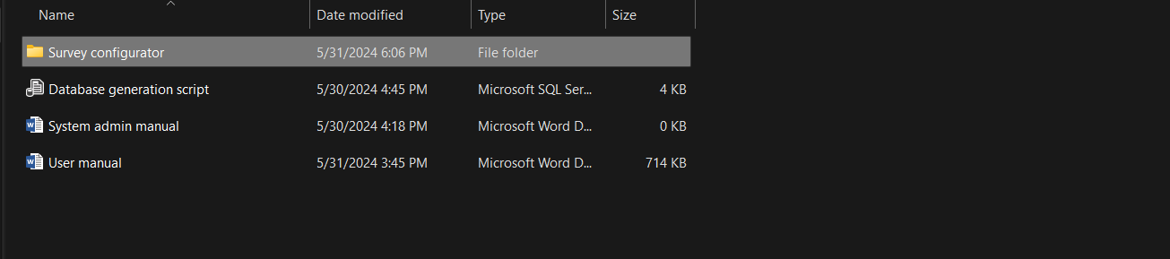

## 1.3 Setting up the database

-After unpacking the file open the “Database generation script” file, it will open the SQL server management studio application connect to your database using your credentials, if a query page doesn’t show up on the screen just reopen the “Database generation script” file again while the SQL server management studio is running, and you should be able to see the following screen:

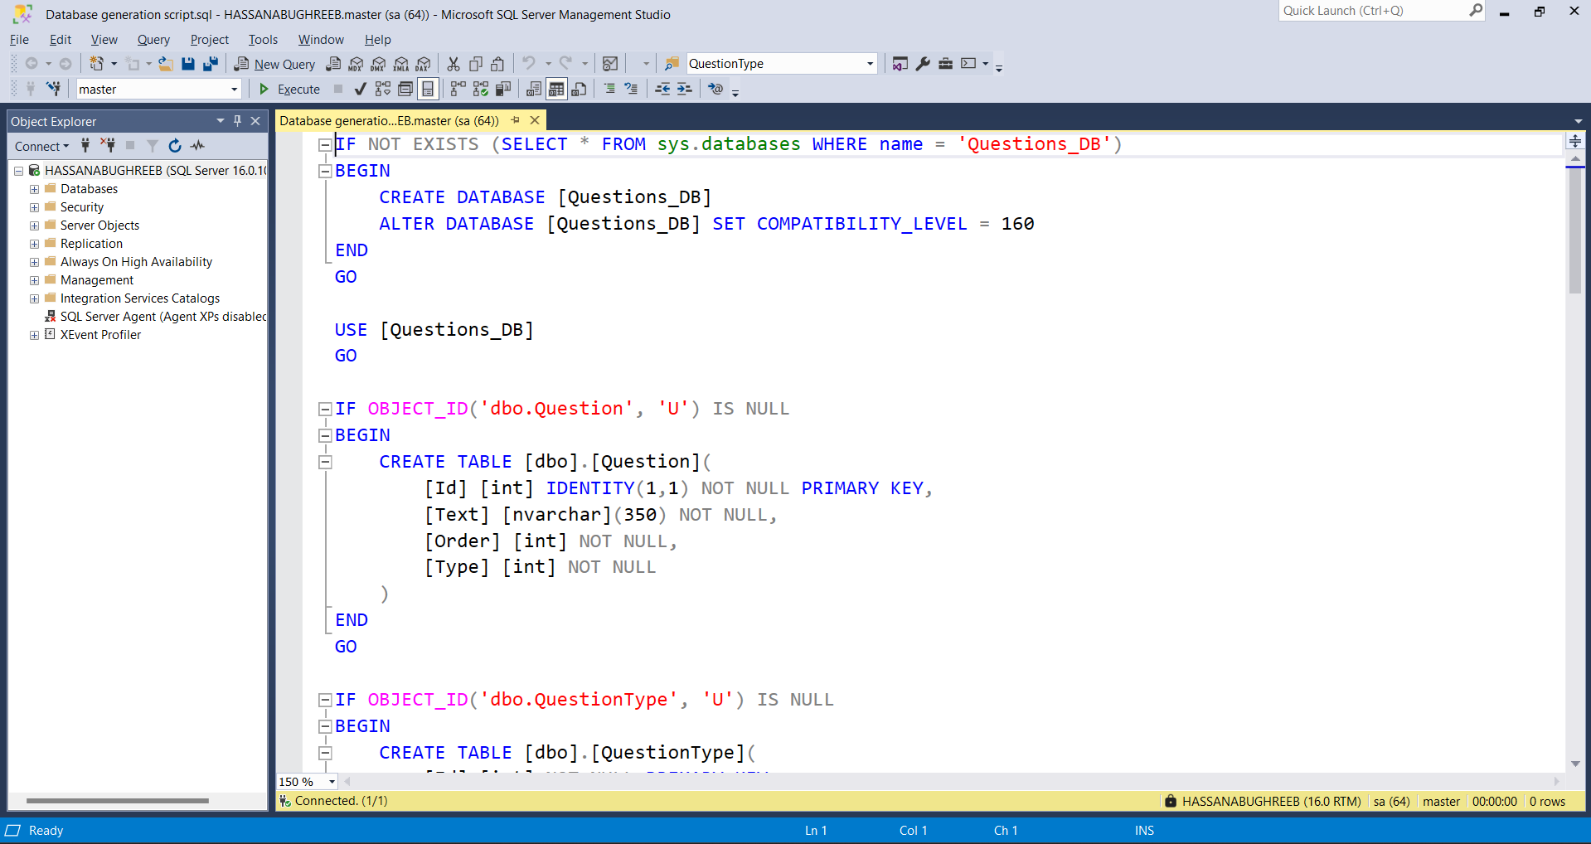

-press on Execute to run the query and create the database.

## 1.4 Setting up the application for the first time

-After running the database generation script, navigate to the “Survey configurator” directory and scroll to the bottom and you should find the “Survey configurator” file: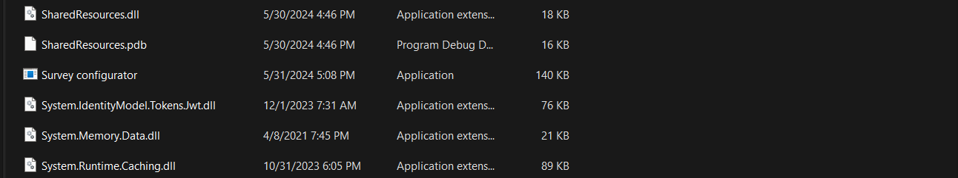

- double click the file and this screen should appear:

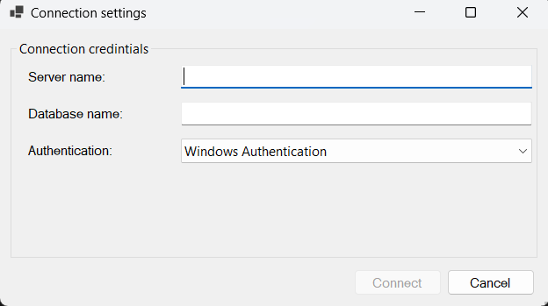

-for the “Server name” field enter the name of you SQL server, and the database name is **Questions_DB**, choose the authentication type you would like to use, either the Windows authentication or the SQL server authentication which requires the same username and password you use to connect to your SQL server and then click on Connect button.

-After connecting to the SQL server the main screen of the application should appear:

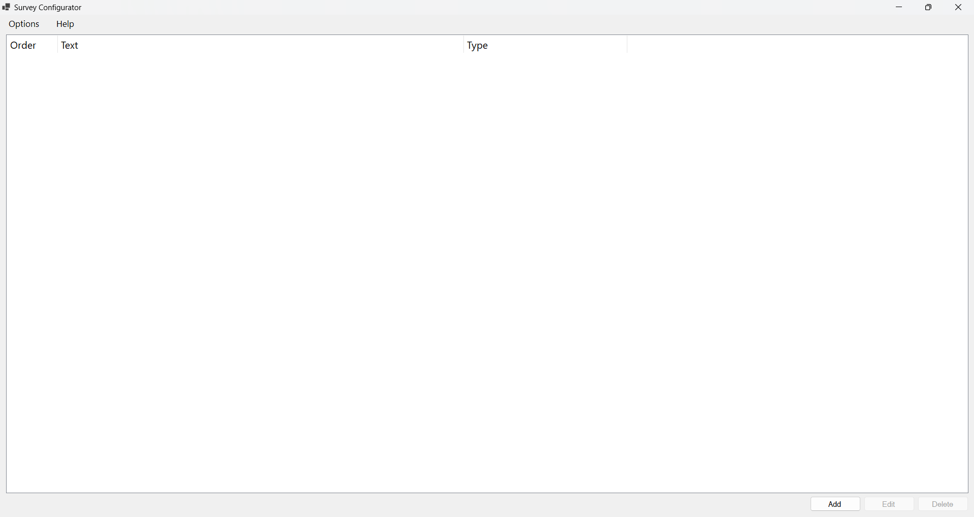

-you can change the language, font size of the application by clicking on the “Options” menu in the menu bar at the top of the screen, changing the language would cause the application to restart.

-and in case of change in the SQL Server connection settings you also can change them from the “Options” menu choosing the “Connection settings” option:

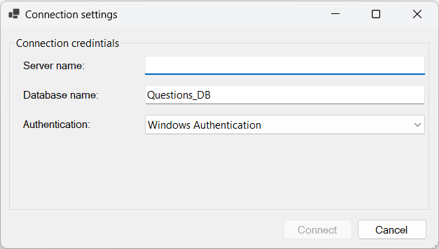

-the window now will contain the settings of the current connection credentials, change the credentials and click connect to connect to the SQL server, or click cancel to close the window.

# 2.0 Troubleshooting

## 2.1 Database connection error

-As the name suggests these errors are caused by failure to connect to the database, a pop up message could appear to the user that there’s a database error, or the app may stop functioning normally, or the app may not open at all due to such error.

-encountering the “Database connection error” warning message while opening the app:

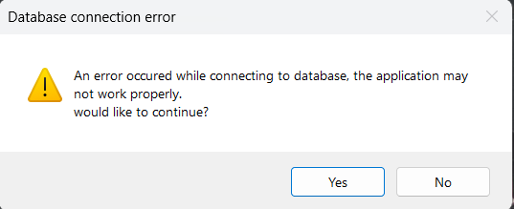

-upon seeing this message you can press no to close the app, or yes to enter the app but it won’t be functioning normally as presented:

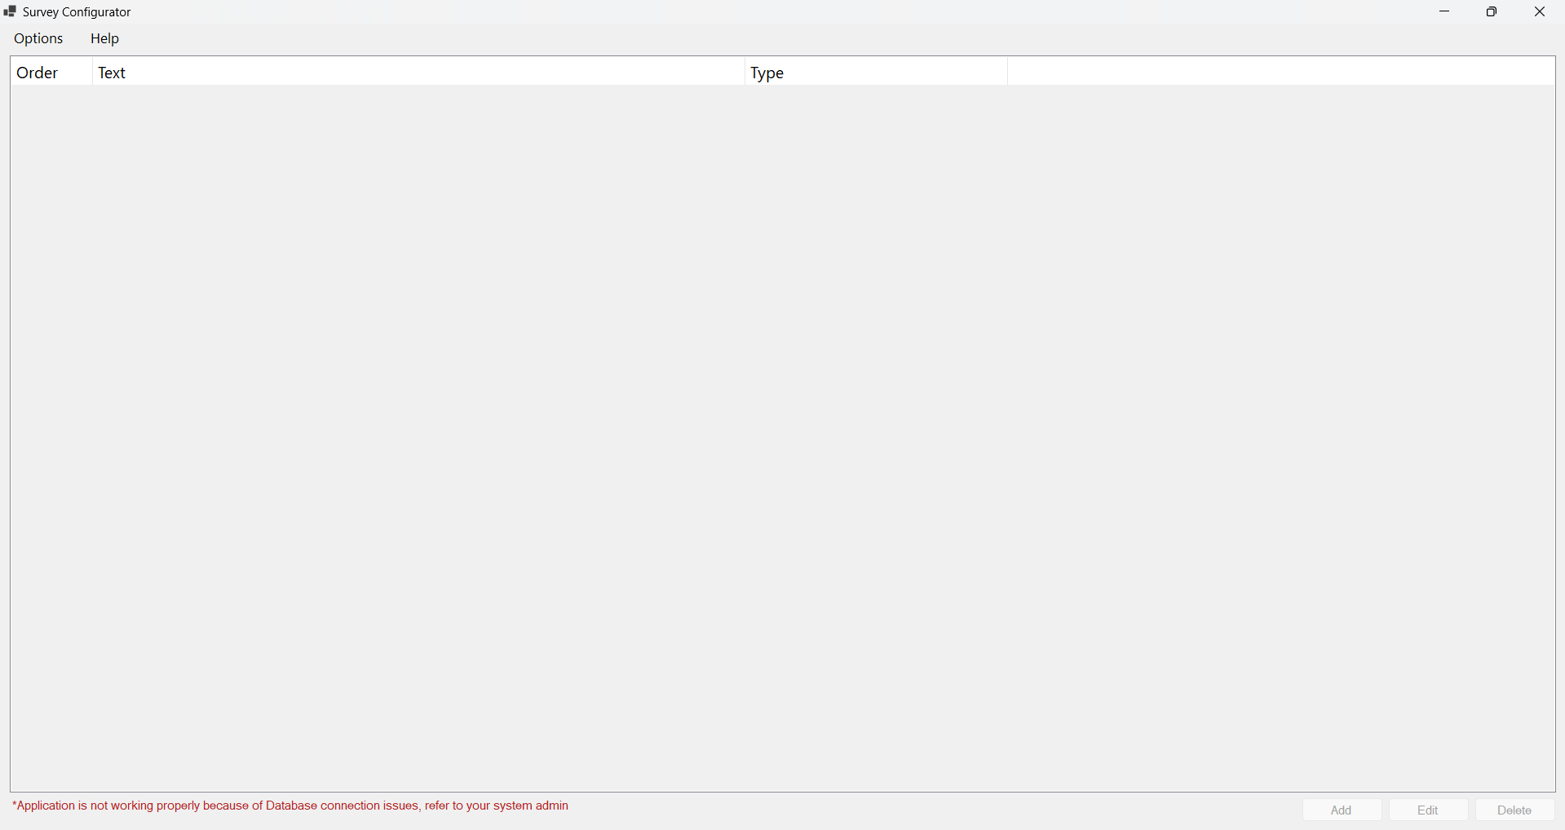

-in this case you can open the “Connection settings” window from the “Options” menu at the top of the screen and re-configure the connection credentials from there.

## 2.2 File access error

-The user may encounter this error due to file access restrictions on the application or the user to solve and avoid this error grant this app the permission to create/read/delete files on the system.

## 2.3 Unknown error

-These errors require a developer to investigate the cause, what you could do in this case is to provide the developer with the error log file in the application folder:

